Programming III – AT3 Project
Product Design Specification
Version 2.0

11/06/2020

By: Sean Boaden
30010353

VERSION HISTORY
Version  # | Implemented  By | Revision  Date | Approved  By | Approval  Date | Reason
1.0 | Sean B | <mm/dd/yy> | Stewart Godwin | <mm/dd/yy> | Initial Design Definition draft
2.0 | Sean B |  |  |  | Changed IPC mechanism to Sockets

TABLE OF CONTENTS
1 Introduction 4
1.1 Purpose of The Product Design Specification Document 4
1.2 Intended Audience 4
1.3 Project Scope 4
2 General Overview and Design Guidelines/Approach 4
2.1 Assumptions / Constraints / Standards 4
3 Architecture Design 4
3.1 Hardware Architecture 4
3.2 Software Architecture 4
3.3 Security Architecture 4
3.4 Communication Architecture 4
4 System Design 5
4.1 Client / Server System 5
4.2 User Interface Design 5
5 Functional Requirements 5
5.1 Business Rules 5
5.2 Required Features 5
5.3 Administrative Functions 5
5.4 Authentication 5
5.5 Authorization Levels 5
5.6 Reporting 5
6 Non-Functional Requirements 6
6.1 Performance 6
6.2 UML 6
6.3 Security Requirements 6
6.4 Software Quality 6
7 Product Design Specification Approval 7
Appendix A: References 8

Introduction

Purpose of The Product Design Specification Document
The Product Design Specification documents and tracks the necessary information required to effectively define architecture and system design in order to give the development team guidance on architecture of the system to be developed.

Intended Audience
This project is intended to demonstrate programming concepts to Jupiter Mining Corporation.

Project Scope
This program relies on inter-process communication to demonstrate hashing techniques, and security levels. A server program will be included, and multiple clients will be able to sign in or sign up, validation will be performed on server-side. The client program offers a Music Player service to registered users.

General Overview and Design Guidelines/Approach

Assumptions / Constraints / Standards
Standards to be met include C# Microsoft coding standards,
Jupiter Mining Corporation design standards,
Third-party libraries include CSVHelper,

Architecture Design

Hardware Architecture
This program will be designed and implemented with the intention to release to Desktop computers.

Software Architecture
Windows is currently the only supported platform in .NET Framework, and will be the required OS for this project.

Security Architecture
User accounts will be classified as: guest, registered user, or admin. They each will have special permissions and any security authentication is performed on the server-side.

Communication Architecture
An IPC system will be implemented in this project to fulfill the hashing requirements. The IPC mechanism to utilise will be Sockets.

System Design

Client / Server System
The application will use a Multiple Client-Server set up with Sockets to communicate.

User Interface Design
The front-end and back-end will be programmed in C# .NET Framework using Windows Forms. The UI prototype can be viewed here (page 2).

Functional Requirements

Business Rules
The application must conform to the Business Rules set out by Jupiter Mining Corporation.

Required Features
The music app will store songs in a binary tree. The playlist library will be saved on the client side.
Song sorting is available and will sort the selected playlist using merge sort.
Song search will perform binary search for a song among playlists.
Hashing techniques will be used when a user logs in.
Third-party libraries to use are CSVHelper, and the user will have the option to save their playlist library to a CSV.

Administrative Functions
The Admin users will be able to add and view accounts.

Authentication
Standard hashing techniques will be used to authenticate registered users. Guests will not need to be authenticated. When a user registers for an account, they will have their name and password (password hash/salt) stored on the server-side. When they log in, they will be authenticated against their stored credentials.

Authorization Levels
Admin is the most authorized account type, and has full functionality of the program.
The Registered User will be able to access the Music Player application, and will be able to view their account details.
Guests will have access to almost nothing.

Reporting
Tests and debugging will be documented during the development process.

Non-Functional Requirements

Performance
The merge sort and binary search algorithms should provide a good performance. Granted the playlist size is not large, ( > 5000 elements in one list ) the merge sort algorithm will perform well on new machines. Merge sort has only one fault, and that is the O(n) space complexity when performing sorts. For this reason, operations on large data quantities will require lots of memory.
Binary Search is one of the fastest search algorithms

UML
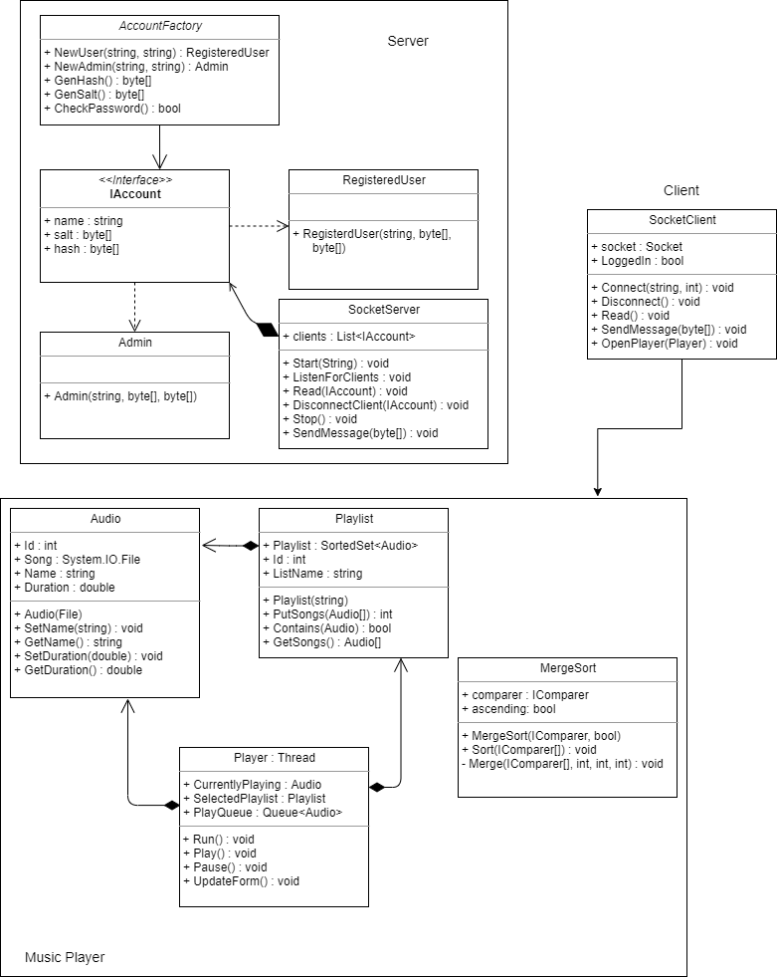

Security Requirements
Jupiter Mining Corporation has not provided any security requirements, though none should be needed for a project of this size and scope.

Software Quality
Maintainability: The program should be easy to maintain if any future work needs to be done.
Usability: The user interface should follow pre-existing design standards for user interactibility.

Product Design Specification Approval
The undersigned acknowledge they have reviewed the Jupiter Mining Product Design Specification document and agree with the approach it presents. Any changes to this Requirements Definition will be coordinated with and approved by the undersigned or their designated representatives.

Signature: | ✓ | Date: | 31/05/2020
Print Name: | Sean Boaden
Role: | Developer

Signature: |  | Date:
Print Name: | Stewart Godwin
Title: | Dr
Role: | Jupiter Mining Corp. Representative

Appendix A: References
[Insert the name, version number, description, and physical location of any documents referenced in this document. Add rows to the table as necessary.]
The following table summarizes the documents referenced in this document.
Document Name and Version | Description | Location
Blackboard Learning Content | The content provided by lecturers is available on Blackboard | Link
C# Microsoft Coding Standards | Industry standards which apply to the C# language, defined by Microsoft | Link
CSVHelper | CSVHelper library by Josh Close | https://joshclose.github.io/CsvHelper/

